Date: 04.06.2021
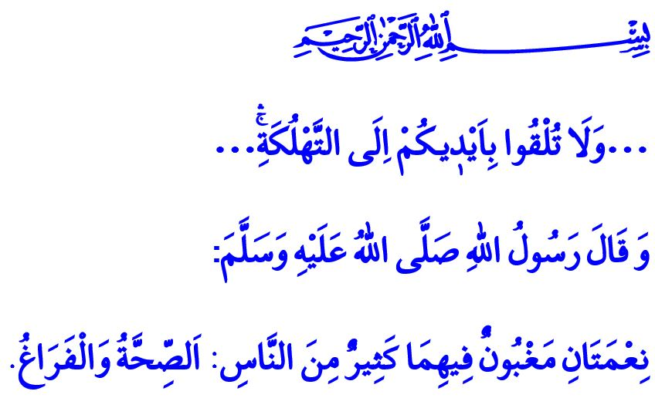
ISLAM PROHIBITS HARMFUL HABITS
Honorable Muslims!
Our sublime religion Islam enjoins the protection of life, property, mind, religion, and posterity. Everything that is useful and clean for a healthy and peaceful life is regarded halal, and everything that is harmful is regarded haram in Islam. Harmful habits that damage human mind and body, too, are included in what is regarded haram. This is because harmful habits that threaten human health and undermine spirituality not only waste people’s life entrusted by our Lord (swt) but also deplete one’s property and wealth that should be spent in charitable works.
Dear Believers!
Today, cigarette smoking (tobacco use) comes on top of harmful habits that surround humanity. A cigarette contains many harmful ingredients and substances in it and destroys human body slowly. Cigarette smokers, in effect, prepare their end with their own hands and endanger first and foremost the health of their own and their family as well as that of others around them by intoxicating the air we breathe in. How sad it is that over one hundred thousand people in our country lose their lives due to smoking-related illnesses every year. However, Allah the Almighty (swt) states as follows, “Do not throw [yourselves] with your [own] hands into destruction.”

Dear Muslims!
A lot of research conducted in recent years has scientifically proven that cigarette smoking has many adverse effects on human health. Taking into consideration the damages it inflicts on both the smoker and their environment, it is clear that it can be safely interpreted as trespassing the boundaries set out by Allah (swt). For this reason, smoking a cigarette, which contains several harms, is not permissible for Muslims.
Moreover, squandering and spending our wealth irresponsibly constitutes an act of wastefulness. Wastefulness is haram in Islam. The Almighty Allah (swt) commands that we act responsibly, be cognizant of the value of blessings, and avoid wastefulness, by stating as follows, “... Eat and drink, but be not excessive. Indeed, He likes not those who commit excess.”
Dear Believers!
In a similar vein, the Prophet Muhammad (saw) informs us that one of the two blessings many people do not know the value of is health.
For this reason, let us appreciate the value of a healthy breath and a healthy body. Let us keep up our sensitivity, which increased in the pandemic period, also against cigarette smoking and other harmful habits. Let us fight, collectively as a nation, for our children and youth not to fall into these kinds of traps. Let us work together to raise healthy, peaceful, and happy generations.

Baqarah, 2/195.
A’raf, 7/31.
Bukhari, Riqaq, 1. General Directorate of Religious Services

